HDOC DAY - 15 ACTIVITY

Question 1: Moment of Inertia of a Disc
Problem Analysis
Problem: Find the moment of inertia of a disc when its mass and radius are given.

Input:
Mass of disc m in kg
Radius of disc r in m

Output: Moment of inertia I in kg·m²

Formula:
I = ½ mr^2

Standard Test Case Table:
Test Case | Inputs: m, r | Expected Output | Actual Output | Result
1 | 2, 3 | 9.00 | 9.00 | Pass
2 | 4, 2 | 8.00 | 8.00 | Pass
3 | 10, 1 | 5.00 | 5.00 | Pass

Algorithm:
- Start.
- Declare variables mass, radius and inertia.
- Input the mass of the disc.
- Input the radius of the disc.
- Calculate inertia = 0.5 × mass × radius × radius.
- Display the moment of inertia.
- Stop.

C Program:

#include <stdio.h>

int main()
{
float mass, radius, inertia;

printf("Enter mass of disc (kg): ");
scanf("%f", &mass);

printf("Enter radius of disc (m): ");
scanf("%f", &radius);

inertia = 0.5 * mass * radius * radius;

printf("Moment of inertia = %.2f kg m^2\n", inertia);

return 0;
}

Evaluation:
The program was tested using the test cases given above. The actual outputs matched the expected outputs; therefore, all test cases passed.

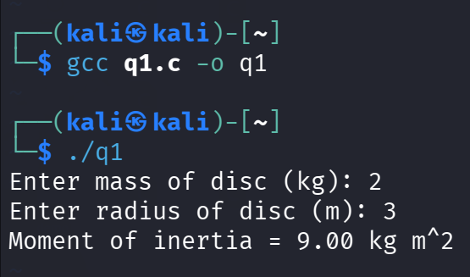

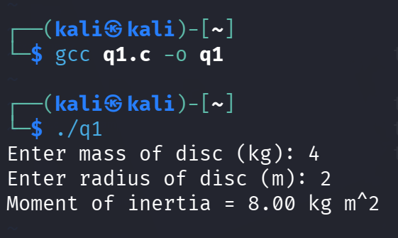

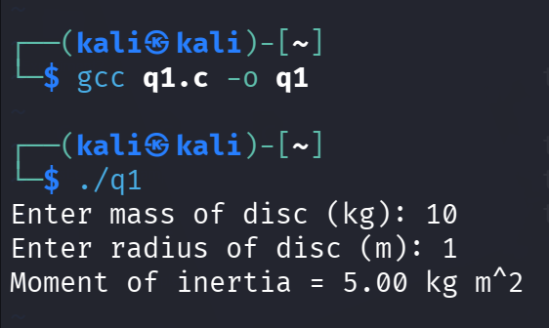

Question 2: Pressure Energy per Unit Volume

Problem Analysis
Problem: Find pressure energy per unit volume when pressure is given.

Input: Pressure P in Pascal (Pa)

Output: Pressure energy per unit volume in J/m³

Formula:
E/V = P
Since 1 Pa = 1 J/m³, pressure itself represents pressure energy per unit volume.

Standard Test Case Table:
Test Case | Inputs: Pressure | Expected Output | Actual Output | Result
1 | 100 | 100.00 | 100.00 | Pass
2 | 500 | 500.00 | 500.00 | Pass
3 | 1000 | 1000.00 | 1000.00 | Pass

Algorithm:
- Start.
- Declare variables pressure and energy.
- Input the pressure.
- Calculate energy = pressure.
- Display the pressure energy per unit volume.
- Stop.

C Program:
#include <stdio.h>

int main()
{
float pressure, energy;

printf("Enter pressure (Pa): ");
scanf("%f", &pressure);

energy = pressure;

printf("Pressure energy per unit volume = %.2f J/m^3\n", energy);

return 0;
}

Evaluation:
The program was executed for all three test cases. The actual outputs were equal to the expected outputs, so all test cases passed.

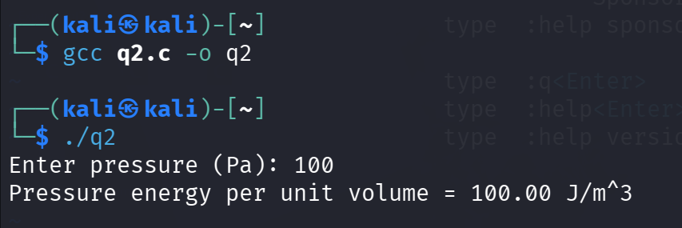

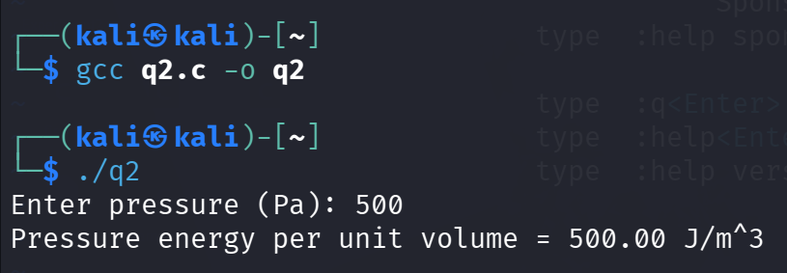

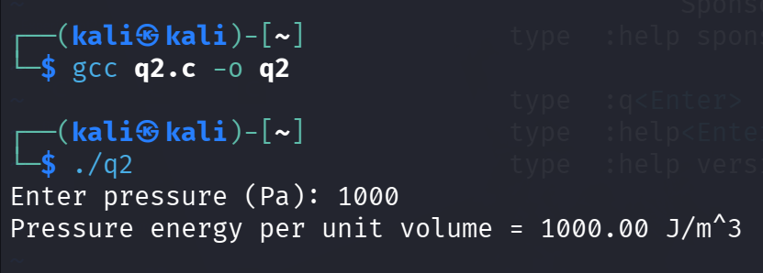

Question 3: Real Depth from Apparent Depth

Problem Analysis
Problem: Find the real depth when apparent depth and refractive index are given.

Input:
Apparent depth AD
Refractive index μ

Output: Real depth RD

Formula:
u = Real depth/Apparent Depth

Therefore,
RD = p * AD

Standard Test Case Table:
Test Case | Inputs | Expected output | Actual Output | Result
1 | 10, 1.5 | 15.00 | 15.00 | Pass
2 | 20, 1.33 | 26.60 | 26.60 | Pass
3 | 15, 1.4 | 21.00 | 21.00 | Pass

Algorithm:
- Start.
- Declare variables apparentDepth, refractiveIndex and realDepth.
- Input the apparent depth.
- Input the refractive index.
- Calculate realDepth = apparentDepth × refractiveIndex.
- Display the real depth.
- Stop.

C Program:
#include <stdio.h>

int main()
{
float apparentDepth, refractiveIndex, realDepth;

printf("Enter apparent depth: ");
scanf("%f", &apparentDepth);

printf("Enter refractive index: ");
scanf("%f", &refractiveIndex);

realDepth = apparentDepth * refractiveIndex;

printf("Real depth = %.2f\n", realDepth);

return 0;
}
Evaluation:
The program was checked against all the prepared test cases. The actual outputs matched the expected outputs, hence all test cases passed

